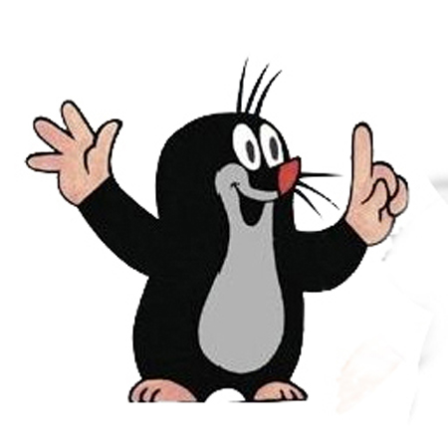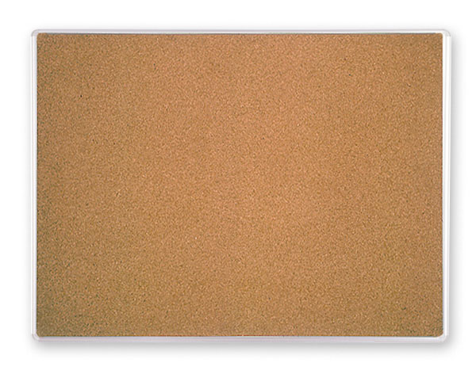

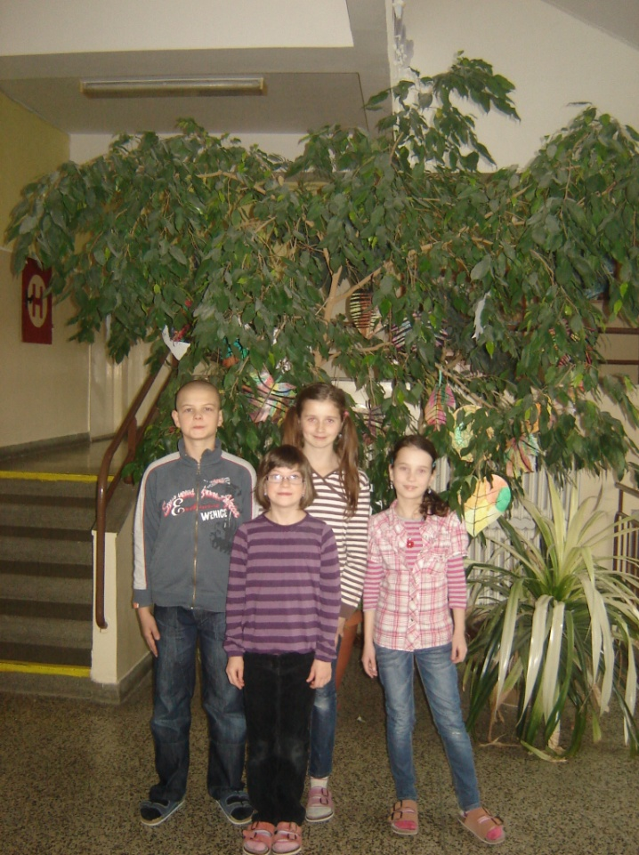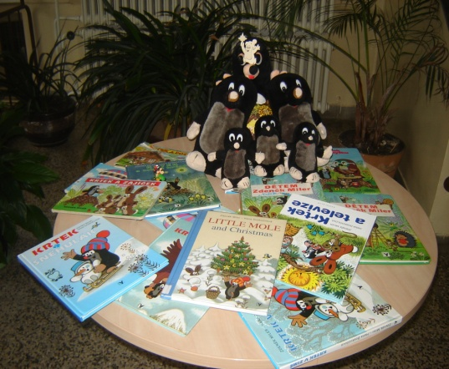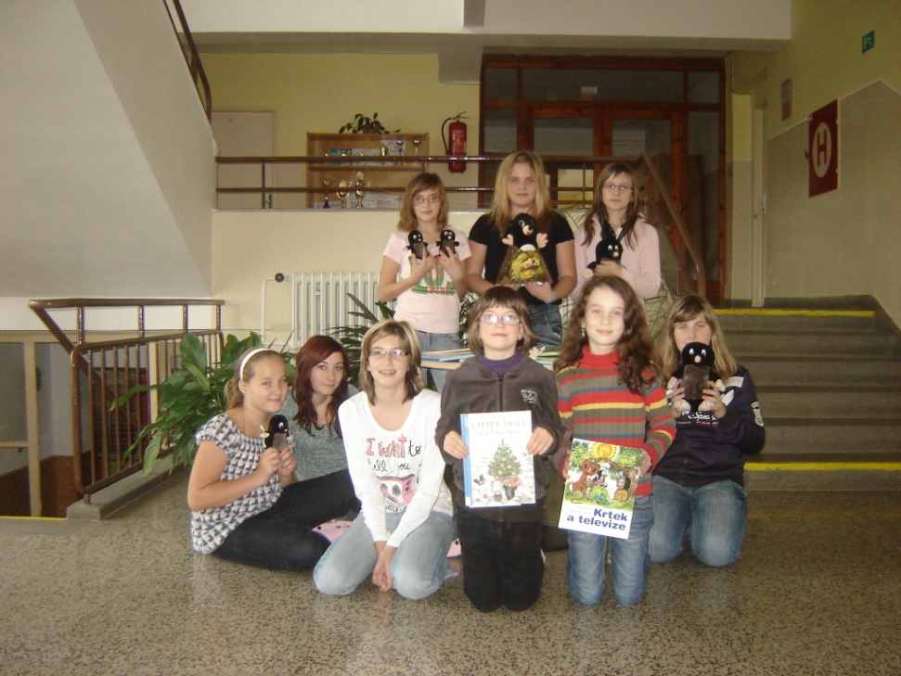

Zden*ě*k Miler

Zdeněk Miler was a Czech artist and director of animated films for children. He wrote a story about little mole, which is known as the **KRTEČEK** in the Czech Republic.

Little Mole and Christmas



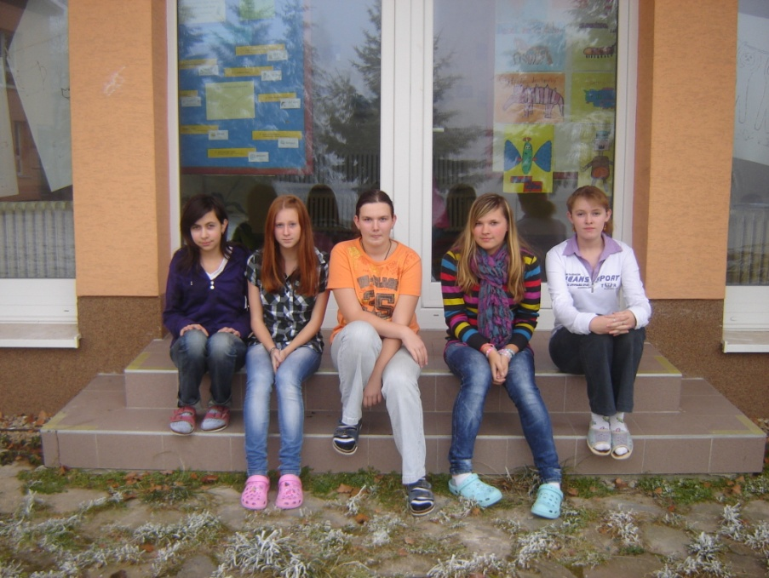

C:\Users\Martina\AppData\Local\Microsoft\Windows\Temporary Internet Files\Content.IE5\INY32NBX\MC900430075[1].wmf





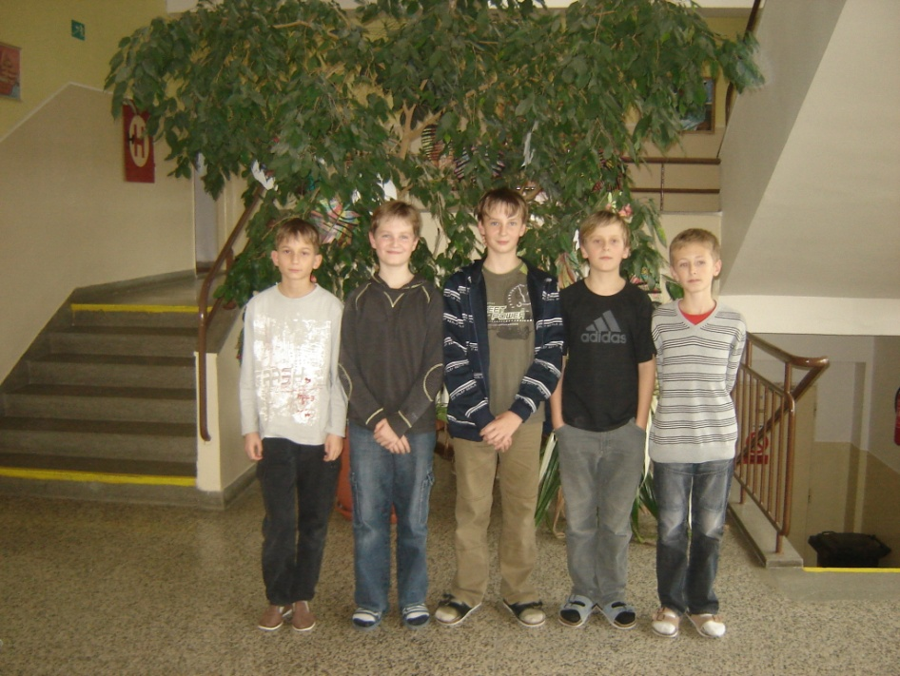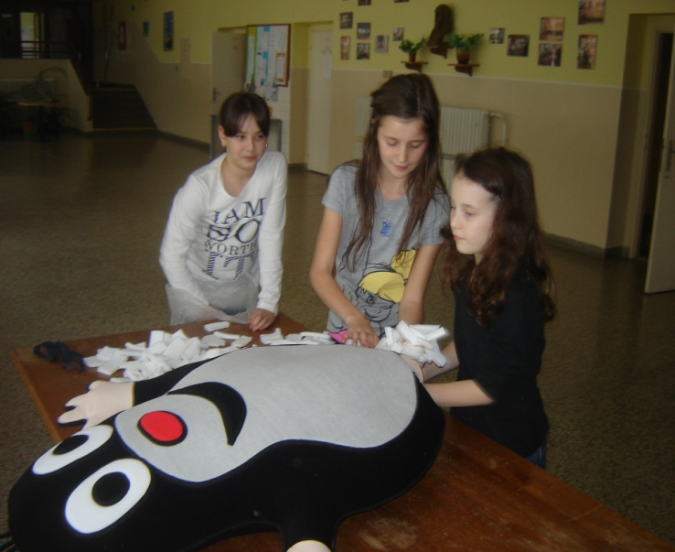

This is our mole

C:\Users\Martina\AppData\Local\Microsoft\Windows\Temporary Internet Files\Content.IE5\ZH6RGNTD\MC900438247[1].wmf





Our school is cool!

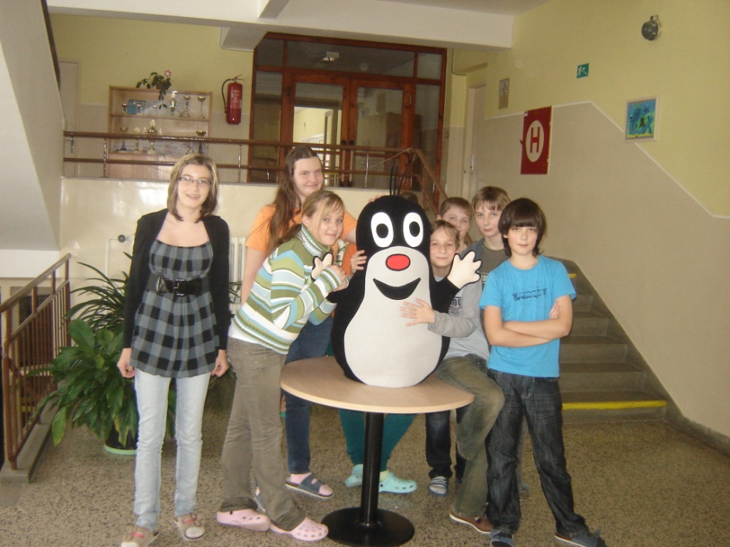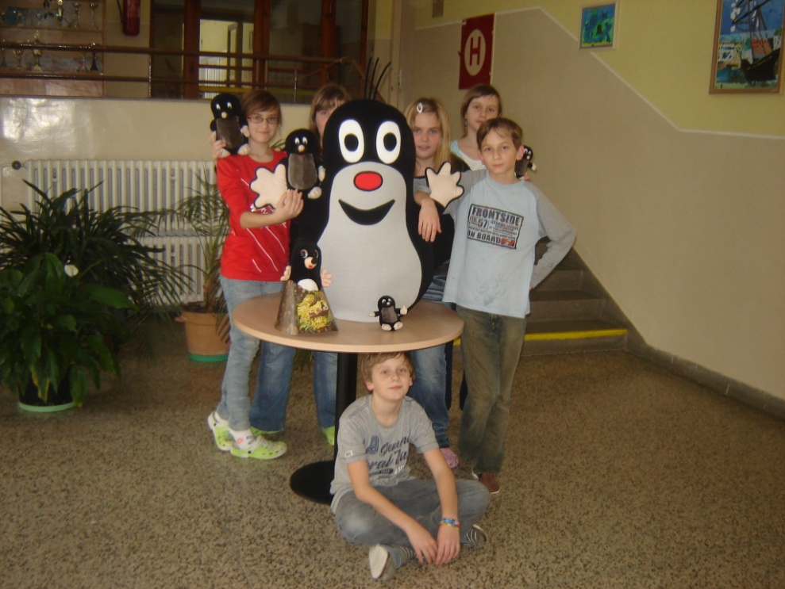





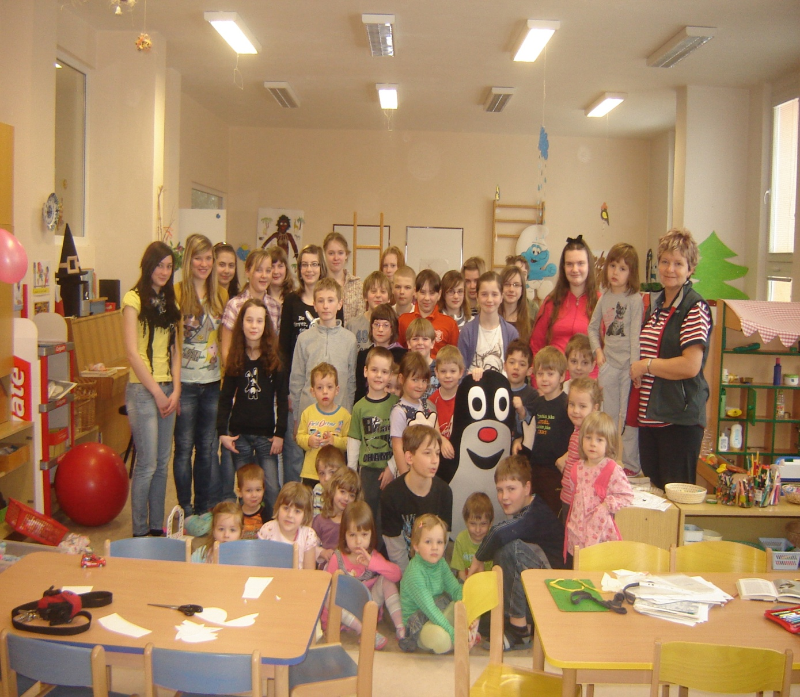



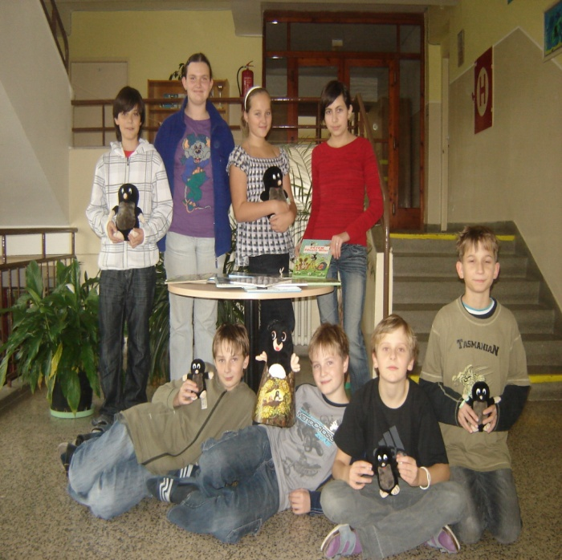

C:\Users\Martina\AppData\Local\Microsoft\Windows\Temporary Internet Files\Content.IE5\281BRY2X\MC900305467[1].wmf



We and our nursery school